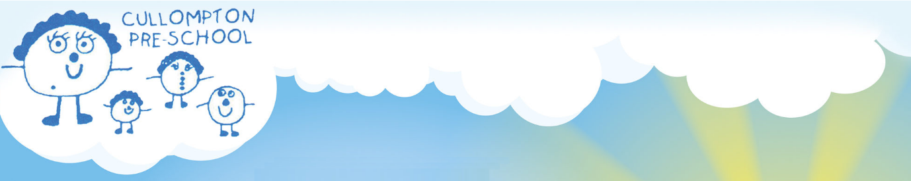

1.24 Dummy Policy
Cullompton Pre-School

Policy Statement
It is understood that when children start pre-school they may be using a dummy or are still having a bottle. The Department for Children, School and Families have issued a document called “Supporting children with speech, language and communication needs: Guidance for the Early Years Foundation Stage”, from which the following quotation can be found: “Dummies and bottles can contribute to delayed communication development”.
Babies and young children spend lots of time making sounds and exploring their own mouths and voices before they begin to use words. In doing so they are not only practicing and developing the skills needed for speech but they are also encouraging other people in the world to notice them and communicate with them. Children who suck dummies through the day make fewer sounds, gain less experience of using their voices, and hear less language from adults around them.
If toddlers are allowed to continue to suck a dummy and talk with it in their mouths, there is also a risk that the child will learn distorted patterns of speech because the teat prevents normal movements at the front of their mouth. These patterns may be difficult to change later on. Although a dummy or bottle can be a source of comfort when a child is upset, and may form part of a child’s sleep routine, parents should be encouraged to use it only at these times, and to phase out dummies and bottles as soon as possible.

Procedure
In the light of this information, the pre-school would strongly recommend that children who use a dummy refrain from bringing it to the setting. However, should the removal of the dummy cause considerable upset and consequently the child is unable to settle, special compensation will be given. Where necessary, each child will be given an appropriate personalised strategy, over a six week period, agreed between the pre-school and parents to encourage the phasing out of the dummy and or bottle. A comprehensive leaflet and advice will be given by the keyperson at a meeting. In exceptional circumstances, as agreed by the SEN co-ordinator or the Pre-School Leader, a bottle will be allowed to be kept in the kitchen but children will be encouraged to use the water cooler.
Guidance: ‘Supporting children with speech, language and communication needs: Guidance for the Early Years Foundation Stage.

This policy has a bi-annual review period from 2024 onwards and, as such, will be reviewed and signed off at a management committee meeting of Cullompton Pre-School, as shown below.

Adopted on:- | 26th February 2018 | by | Owen Jones  Chairperson
Previously reviewed on:- | 25th February 2019 | by | Alex Fox  Chairperson
Previously reviewed on:- | 24th February 2020 | by | Alex Fox  Chairperson
Previously reviewed on:- | 24th January 2022 | by | Jack Madge  Chairperson
Previously reviewed on:- | 22nd February 2023 | By | Hannah Tilley
Previously reviewed on:- | 20th April 2024 | By | Jess Titcombe

Reviewed by Staff on: | February 2026
Reviewed by Committee on:

Date of next review: | March 2028
Signed on behalf of the Management
Committee:
Name of Signatory (printed):

Role of Signatory (e.g. Chairperson)

